2009
DELHI TECHNOLOGICAL UNIVERSITY

By:
- Kanika Vats
(2k6/IT/932)
- Kartik Rustagi
(2k6/IT/934)


[Distributed peer to peer system over Lan]
Use the Gnutella specification describing the various data structures, messages and other subtleties of a Distributed Peer to Peer (P2P) system to implement them in a Local Area Network (LAN) topology.

INDEX

SNO | TOPIC | PAGE NUMBER
1 | ACKNOWLEDGMENT | 3
2 | ABSTRACT | 4
3 | MAJOR TASKS | 5
4 | ABOUT PEER TO PEER | 6
5 | GNUTELLA SPECIFICATION | 8
6 | GNUTELLA FEATURES | 9
7 | LANGUAGE WE USED AND WHY? | 11
8 | MESSAGE HANDLING | 12
9 | PONG CAHING | 14
10 | SEARCHING | 15
11 | FILE SHARING | 16
12 | AUTOMATIC IP DETECTION | 17
13 | INSTRUCTIONS FOR SOFTWARE INSTALLATION | 18
14 | INSTRUCTION FOR EXECUTING AND USING THE SOFTWARE | 19
15 | SOFTWARE REQUIREMENTS | 20
16 | FUTURE GOALS | 21
17 | REFERENCES | 22
18 SOURCE CODE
Acknowledgement

We are very thankful to Ms. Richa Gupta for her continuous support and excellent mentorship throughout the process of completion of this project.

Abstract

As a part of our Minor Project in 7th semester in Information Technology from Delhi Technological University, We have done a project on Distributed Peer to Peer System over LAN. Our aim was to understand the Gnutella specification that describes the various data structures, messages and other subtleties of a Distributed Peer to Peer (P2P) system over Internet and implement the same for a Local Area Network (LAN) topology.

OBJECTIVE

● To provide a File Search and Transfer application for Local Area Network which is 'Pure peer to peer' i.e. independent of any central server. P2P software’s available in the market for the Internet are not pure p2p that is they require a central server to monitor status of the nodes.

● It is not always possible to have a central server available 24*7 to monitor file transfer in LAN environment like those of an education institute's hostel or any other organization. Therefore we aim to have a protocol which is pure p2p in nature.

MAJOR TASKS

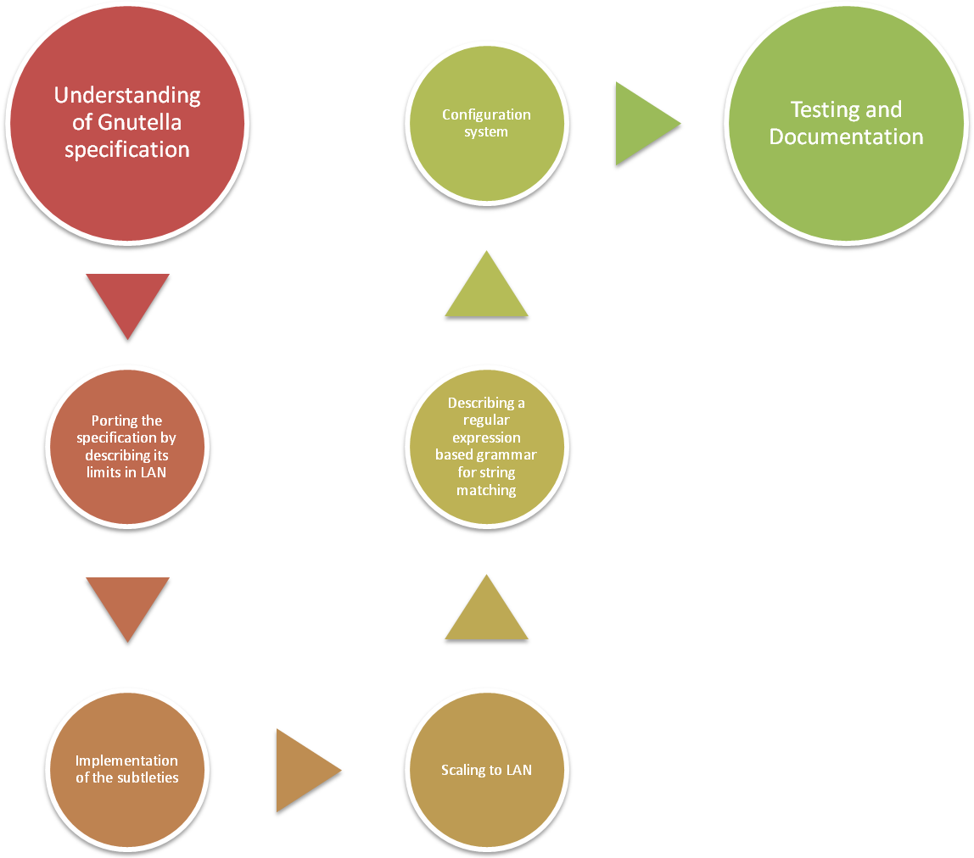
WHAT IS PEER TO PEER PROGRAMMING??
P2P networks are typically used for connecting nodes via largely ad hoc connections. Such networks are useful for many purposes. Sharing content files (see file sharing) containing audio, video, data or anything in digital format is very common, and real-time data, such as telephony traffic, is also passed using P2P technology.
A pure P2P network does not have the notion of clients or servers but only equal peer nodes that simultaneously function as both "clients" and "servers" to the other nodes on the network. This model of network arrangement differs from the client-server model where communication is usually to and from a central server. A typical example of a file transfer that is not P2P is an FTP server where the client and server programs are quite distinct, the clients initiate the download/uploads, and the servers react to and satisfy these requests.
In 'pure' P2P networks:
- Peers act as equals, merging the roles of clients and server
- There is no central server managing the network
- There is no central router

Advantages of P2P networks
An important goal in P2P networks is that all clients provide resources, including bandwidth, storage space, and computing power. Thus, as nodes arrive and demand on the system increases, the total capacity of the system also increases. This is not true of a client-server architecture with a fixed set of servers, in which adding more clients could mean slower data transfer for all users.
The distributed nature of P2P networks also increases robustness in case of failures by replicating data over multiple peers, and -- in pure P2P systems -- by enabling peers to find the data without relying on a centralized index server. In the latter case, there is no single point of failure in the system.

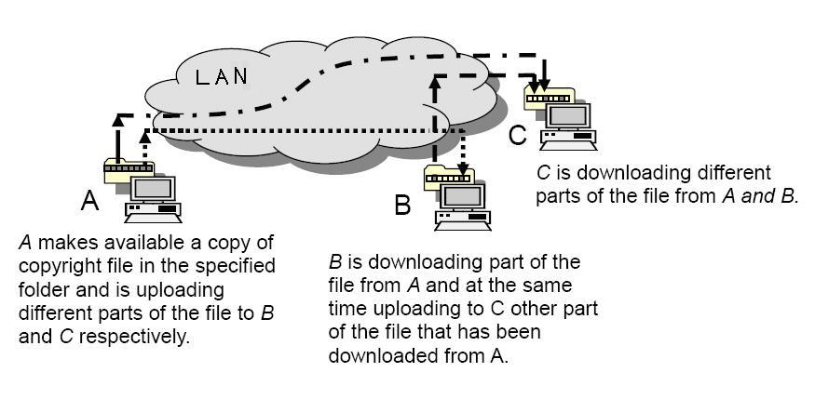
AS WE CAN SEE IN ABOVE PICTURE FILE SHARING IS TAKING PLACE WITH THE HELP OF P2P OVER LAN,
IMPORATNT POINTS TO CONSIDER ARE:
- Peers act as equals, merging the roles of clients and server
- There is no central server managing the network
- There is no central router

Gnutella Specification

The Gnutella protocol provides a simple reliable distribution system that delivers data to all. There are no central servers. The network is based on peers that co-operate independently to make a library of digital content.
Gnutella is a protocol for distributed search. Although the Gnutella protocol supports a traditional client/centralized server search paradigm, Gnutella’s distinction is its peer-to-peer, decentralized model. In this model, every client is a server, and vice versa. These so-called Gnutella servants perform tasks normally associated with both clients and servers. They provide client-side interfaces through which users can issue queries and view search results, while at the same time they also accept queries from other servants, check for matches against their local data set, and respond with applicable results. Due to its distributed nature, a network of servants that implements the Gnutella protocol is highly fault-tolerant, as operation of the network will not be interrupted if a subset of servants goes offline.

Usage of Gnutella:
Gnutella is used as the backbone for most of the commercial P2P file search software like Limewire , Ares etc.

Gnutella Features

The Handshake
The Gnutella Handshake is the first interaction two Gnutella programs make when one connects to another. The programs advertise which features they support, and negotiate how they will communicate. A Gnutella connection begins with 3 groups of text headers followed by an endless stream of Gnutella messages. The text headers and initial messages make up the handshake.

Pong Caching
Gnutella is a self-organizing network. There's no central server to coordinate Gnutella programs and tell them what to do. This means that the services central servers usually provide have to be built into every Gnutella program, and carefully executed in a balanced way.
One such service is discovery: knowing the IP addresses of other Gnutella programs on the Internet to try to connect to. Gnutella programs can be online for only several minutes or less. This makes a constant stream of current addresses a vital necessity to a Gnutella program. The modern Gnutella network provides this information to its programs through a distributed system called pong caching.

Search
Search engines like Google crawl the Web, making an index of pages on large central servers. Without any central servers, search on Gnutella has to work differently. A Gnutella program makes a Query message that holds the search the user typed. It sends the message to its connected peers, and they send it onward, routing it into the network. Programs that get the query check to see if any of their shared files match. A program with a hit makes a message about it and routes it back to the searching program.

File Transfer

File Transfer takes place through TCP connection whereas messages exchanged for connection establishment takes place through UDP connection.

LANGUAGE WE USED AND WHY ?

We have implemented our P2P protocol via Python because Python offers a simple interface (much simpler than the corresponding C implementation, though based on this one) to properly create and use a socket. The various added advantages are as follows:

- Python defines a socket () function returning a socket object. The socket has several methods, corresponding to their pairs from C sys/socket.h, like bind(), connect(),listen() or accept().

- Programmers accustomed with socket usage under C language3 will find very easy to translate their knowledge in the more-easy-to-use socket implementation under Python.

- Python eliminates the daunting task of filling structures like sockaddr_in or hostent and ease the use of previously mentioned methods or functions .

- Parameter passing and functions call are easier to handle.

- Some network-oriented functions are provided too: gethostbyname(),
getprotobyname() or conversion functions ntohl(), htons(),
useful when converting integers to and from network format.

- Python provide beside socket, additional modules (in fact there is a whole bundle of them)supporting the most common network protocols at user level. For example we may find useful modules like httplib, ftplib, telnetlib, smtplib.

- There is implemented support for CGI scripting through cgi module,
a module for URL parsing, classes describing web servers and the examples may continue.

MESSAGE HANDLING (HANDSHAKING)
DESIGN OF MESSAGING SYSTEM:

Before beginning to write any code, we must first think about the design of the P2P protocol that we wish to implement. For a true, "pure" P2P network, every node (computer) will be running the exact same set of algorithms and code and there is no centralized server or any special node to keep status of peers, that is which peers are online and which are not. Thus, we need to decide on the set of messages that the various nodes will exchange between each other and then focus on the behavior of a single node when it receives each type of message. And hence we designed a Protocol to handle all the messaging needs of our application. These messages are sent and received via UDP.

In the protocol that we designed and developed there are 7 types of messages:

• <pr1>: There are two types of messages that will be exchanged between the existing peers in order to declare their presence to others. Thus when a peer will start this application it will declare its presence by sending a message”<pr> I am online” to all the possible IP address
range of the LAN .

• <pr2>:All the existing peers to which the above mentioned tag containing message is send will reply back to mark their presence by sending a message “<pr2> I am online too”.As the above mentioned messages will be exchanged between the existing peers, each peer will
Simultaneously update and maintain a list of the addresses of all the peers.

• <close>: Whenever a system running this application is going to go offline it sends a message containing I am going to be offline with this tag in it, telling all the peers about its future absence ,whenever this message is obtained by its peers they delete the corresponding address of the system from their peer list.

• <srr>: Whenever a peer wants to search for a file among all the peers currently on the network, it sends a string with this tag along with the name of the file.

• <srs>: The peers accept message with tag <srr> and sends the result as '<srs>Yes' indicating success while searching for the file and '<srs>No' to indicate a negative result.

• <Begin>: When the peer that requested a file to be searched receives a positive reply in the form of '<srs>Yes', it asks for that peer to begin file transfer by sending '<Begin>'

• <End>: This tag is sent to indicate completion of a file transfer.
Other then these peers another important part of out protocol is a list Peers, which is used to maintain the status of peers in the network.

THE BEGIN AND END MESSAGES ARE USED TO MARK THE INITIATION OF FILE TRANSFER,THUS AS THESE MESSAGES ARE EXCHANGED THE CORRESPONDING TCP CONNECTION IS ALSO ESTABLISHED BETWEEN THE TWO PEERS THROUGH WHICH FILE TRANSFER WILL TAKE PLACE.

PONG CACHING
In our implementation of Gnutella specification over LAN we achieve pong caching by maintaining a dynamic list of active peers called “peers”. This lists maintains a record of IP addresses of all the active peers.
This list is maintained by each and every peer and is dynamically updated as soon as a
- New peer becomes active over LAN
- Existing peer is removed from LAN
This basically helps to keep a track of all the peers available so that whenever a peer asks for a file the file search operation takes place through all the existing peers.
An important advantage of PONG CACHING is that it provides TRANSPARENCY. Since the list is dynamically maintained the peer need not know which peers are currently active and where to look a file for.

SEARCH OPERATION

Whenever a peer wants to search for a file among all the peers currently on the network, it sends a string with the tag “<srr>” along with the name of the file.

All the active peers accept message with tag <srr> and send the result as “<srs>Yes” indicating success while searching for the file and “<srs>No” to indicate a negative result.

We have implemented keyword searching in the following manner:

- Whenever our software is run on a system then it automatically creates a folder “files” in the same directory where the software has been installed. Thus all the keyword search will take place only for files that are there in the file folder. This provides user:

  - Privacy: So that no one can have access to all the contents of a particular peer system.
  - Flexibility: It provides user the flexibility of choosing which files he/she want to share.

- We used Regular Expressions to provide flexibility in keyword searching/matching. Thus for eg:-

If we want to search for a keyword “Hum Aapke Hain Kaun” then all the files with the following names-

    - HUM AAPKE HAIN KAUN (Case Independent)
    - Hum aapke hain kaun (Flexibility in taking into account any no. of spaces)

will match with the initiated keyword search.

File Sharing

Whenever the peer that requested a file to be searched receives a positive reply in the form of '<srs>Yes', it asks for that peer to begin file transfer by sending '<Begin>'.

<Begin> message marks the initiation of a file transfer operation that takes place through TCP. One can transfer any file (VIDEO, AUDIO, TEXT) to the requesting peer.

As soon as the complete file is received the requesting peer send a message with tag <End> to tell the sending peer that it has received the file and at the same time asking it to close the connection .

The file received is stored in the “Files” folder that is there in the same directory in which the software is installed.

Automatic IP address Detection

One of the important requirements for this application to work is that the local IP of a system should be available to it. There is no standard way of knowing a system’s IP. To detect the IP address of a system we have:
- Store the output of the command line utility ‘ifconfig’ in a temporary file.
- Defined a regular expression specifying how the IP address string will be there in the temporary file.
- Parsed the temporary file.
- Do the necessary string manipulation to get the IP address and store it in a file, ‘userip’.

INSTRUCTIONS FOR INSTALLATION
● This software has been tested on python 2.5.2, but it should work on older or newer version of python too (There might be problems with Python 3 due to change in indentation rules).

● To install python you can wither use your distro's packet manager (Synaptic for Ubuntu or yum for Fedora etc.). Or you can install it from the source code which can be obtained from http://python.org/download/

● To make the software work properly first the script permissions.py located at
P2plan/Source code by running the command 'sudo python permissions.py'. This will set the appropriate permissions to the scripts present in p2plan.

INSTRUCTION FOR EXECUTING AND USING THE SOFTWARE
● Current version of the software needs to be operated in 'Terminal' and lacks a Graphical User Interface which will be added in the next version.

● To make it work in Red Hat linux ifconfig needs to be given appropriate conditions. Log in as root and 'chmod 777 /sbin/ifconfig'

● To execute the software first change you current directory to 'p2plan/Sourcecode' by using the command 'cd' ('man cd' to see how it works).

● The files that will be shared by this application needs to be stored in the './files' folder. The application looks for files only in this folder. Therefore have your shared files copied in this folder.

● To start the software execute the command 'python main.py'.

● Close the application from within the software(Higly recomended).

● Also the application uses port 2000 and port 2100.

REQUIREMENTS

Software Requirements
● The current version of the application requires only python (Any available version other that version 3) to run.

Hardware Requirements
● It requires a 100kb of hard disk for installation.

Future Goals

Some of the future work that needs to be done:
- Make it work on windows: change the directory structure
- Make the application handle multiple requests at a time: threading or asynchronous connection
- Provide a graphical user interface

REFERENCES

Gnutella specification for PEER TO PEER applications over INTERNET

SORCE CODE

- MAIN.PY
#!/usr/bin/python
import os
import socket
import string
import sys
import setip
import direc
import time

peers=[] #This list will hold addresses of all the nodes that are active on the Network
STATUS=0 #This works like a Semaphore, avoiding data conflict
path='./files' #This is the location of the folder where files to be shared are stored
global ip #This is the IP address of the system
Directory={}
Directory_index_selected=0

#These are the messages that are communicated to indicate the status of a node/user on the network
online='<pr1>I am online'
reply="<pr2>I am online too"
close="<Close>I am going offline"

class main:
def __init__(self):
pass
def update_peers(self,data1):
#This function is called to update peer nodes about its presence as well a to know which nodes are active.
#This function updates the list data structure adding address of active nodes
global STATUS
global peers
z=string.find(data1,'<pr1>')
if z!=-1:
client.sendto(reply,addrs)
peers.append(addrs)
prlength=len(peers)
print peers," are online"
elif z==-1:
k=string.find(data1,'<pr2>')
if k!=-1:
peers.append(addrs)
prlength=len(peers)
print peers," are online"
def initiate_find(self):
#This function is initiated to initiate a file search operation by a node
global STATUS
global peers
global path
global Directory
global Directory_index_selected
print '-> Enter the file you want to find (Without Extensions).'
self.strn=raw_input('->')
self.strn='<srr>'+self.strn
flag=0
#A directory will be created which will hold file names matching the result along with the address of their respective hosts
Directory_index=0
for i in range(0,len(peers)):
client.sendto(self.strn,peers[i])
rep,addrs=client.recvfrom(1024)
temp=rep.split('<srs>')
#print 'Reply is ',rep
#print 'Reply is from ',addrs
rep=temp[1]
if rep=='Yes':
flag=1
#Recieving name of files that succesfully matched from in this hosts directory
suitable_files_string,addrs=client.recvfrom(1024)
#print 'suitable_files_string is ',suitable_files_string
suitable_files_list=suitable_files_string.split(' ')
#print 'suitable_files_list is ',suitable_files_list
#will add these files to the directory
for j in range(0,len(suitable_files_list)):
Directory_index=Directory_index+1
#Each index stores file name and the host address in a List
Directory[Directory_index]=[suitable_files_list[j],addrs]

if flag==0:
print '-> File not present in peers\'s directory.'
else:
print '-> Files matching Your results are :-'
for s_no,file_name in Directory.items():
print ' %d:%s'%(s_no,file_name[0])
Directory_index_selected=raw_input('Enter the Serial number of file to be downloaded:')
Directory_index_selected=int(Directory_index_selected)
m.filerecieve(Directory[Directory_index_selected][1])
def ifsearch(self,strn):
# strn is the string that has to be searched
# This function is called when ever the node recieves an incoming request to search
global STATUS
global peers
global path
self.strn=strn
#print '-> String to be searched is ',self.strn
if STATUS==1:
client.sendto('<srs>No',addrs)
print '-> STATUS is busy, neglecting search request'
pass
STATUS=1
os.system('pwd')
os.chdir(path)
ldir=os.listdir('./')
flag=0
lendir=len(ldir)
import regex
if(lendir!=0):
appropriate_results=[] #This will store all the file names which are suitable match for the file being searched
for i in range(0,lendir):
#print 'ldir[i] is ',ldir[i]
#print 'self.strn is ',self.strn
#print 'i is ',i
if regex.match_names(ldir[i],self.strn):
flag=1
#print 'File found'
appropriate_results.append(ldir[i])

if flag==1:
client.sendto('<srs>Yes',addrs)
#The list of appropriate results will be conversted to string of appropriate format
#print 'appropriate_results is ',appropriate_results
appropriate_results_string=str(appropriate_results)
appropriate_results_string=appropriate_results_string.replace('[','')
appropriate_results_string=appropriate_results_string.replace(']','')
appropriate_results_string=appropriate_results_string.replace(',','')
appropriate_results_string=appropriate_results_string.replace("'",'')
#print 'appropriate_results_string is ',appropriate_results_string
client.sendto(appropriate_results_string,addrs)
if(lendir==0 or flag==0):
#print '-> File not found'
client.sendto('<srs>No',addrs)
os.chdir('..')
STATUS=0
def filesend(self,strn):
# This function is called when a file needs to be send from a node
print '-> Sending file'
global STATUS
global peers
STATUS=1
self.strn=strn
path='./files'
fstr=path+'/'+self.strn
f=file(fstr,'r')
# Transfer of files is done via TCP for more reliability, error and flow control. Where as messaging system is done via UDP, it being connection less
fssoc=socket.socket(socket.AF_INET,socket.SOCK_STREAM)
fssoc.bind((ip,2100))
data='<fssoc>'
client.sendto(data,addrs)
fssoc.listen(1)
ptosend,atosend=fssoc.accept()
fssoc.close()
while 1:
data=f.readline(5*1024) #Optimize buffer size to improve speed
if data:
ptosend.send(data)
if not data:
breaK
time.sleep(.5)
f.close()
ptosend.close()
STATUS=0
print '-> File sent'
print '\n'
def filerecieve(self,addr):
#This function is called when the nodes needs to recieve a file from another node
print '-> Recieving file....'
global STATUS
global peers
global Directory
global Directory_index_selected
os.chdir('./files')
f=file(Directory[Directory_index_selected][0],'w')
frsoc=socket.socket(socket.AF_INET,socket.SOCK_STREAM)
frsoc.bind((ip,2100))
client.sendto('<Begin>'+Directory[Directory_index_selected][0],addr)
STATUS=1
# Transfer of files is done via TCP for more reliability, error and flow control. Where as messaging system is done via UDP, it being #connection less
#Now the sender has openend a TCP port and is listning for connections
#It will send '<fssoc>' to sender to start the process
data,address=client.recvfrom(1024)
if(string.find(data,'<fssoc>')==0):
print '-> Connection being made to recieve file'
frsoc.connect((addr[0],2100))
#connected to sender via TCP

while 1:
data,address=frsoc.recvfrom(1024)
if data:
f.write(data)
if not data:
break

print '-> File Recieved completely \n'
f.close()
frsoc.close()
STATUS=0
os.chdir('..')
Directory={}
m=main()
#This socket is use for the messaging system
client=socket.socket(socket.AF_INET,socket.SOCK_DGRAM)

import detectip #To detect users IP address
f=file('./userip','r') #This file stores the IP address
ip=f.readline()
f.close()

client.bind((ip,2000))
port=client.getsockname() #Socket address of the UDP socket, binded at port 2000
f=file('./iprange','r') #This file stores the network subnet
s=f.readline()
f.close()
for i in range(1,255): #Sending message to all the nodes in subnet indicating the presence of this node
ladr=((string.replace(s,'x','%d'%i)),2000)
if ladr==port:
continue
client.sendto(online,ladr)
while 1: #This is the main loop which controls the flow of the function
try:
print '-> Press cntrl+c (KeyBoard Interrup) to initiate Search for file operation or to close the application'
data1,addrs=client.recvfrom(1024)

if(string.find(data1,'<pr1>')==0 or string.find(data1,'<pr2>')==0):
m.update_peers(data1)
elif(string.find(data1,'<srr>')==0):
l=data1.split('<srr>')
m.ifsearch(l[1])
elif(string.find(data1,'<Begin>')==0):
temp=data1.split('<Begin>')
m.filesend(temp[1])
elif(string.find(data1,'<Close>')==0):
peers.remove(addrs)
print peers," are online

except KeyboardInterrupt:
STATUS=1
print 'Enter the operation you want to do.'
print '1.Search \n2.Close Connection \n'
data1=raw_input()
if data1=='1':
m.initiate_find()
elif data1=='2':
for i in range(0,len(peers)):
client.sendto(close,peers[i])
client.close()
sys.exit()

- REGEX.PY
#!/usr/bin/python
import re
def match_names(file_to_be_matched,file_without_ext):
#We will first fetch each word and extension in file_without_ext
w=re.split(' ',file_without_ext)
#Now we will create the pattern/RE for matching
p=' *'
i=0
while i<len(w):
p+=(w[i]+'+ *')
i=i+1
#Now matching will be performed
if re.search(p,file_to_be_matched,2)!=None:
return 1
else:
return 0

- Setip.py
#!/usr/bin/python
#This script let the user select network subnet
import os
ldir=os.listdir('./')
flag=0
lendir=len(ldir)
if(lendir!=0):
for i in range(0,lendir):
if ldir[i]=='iprange':
flag=1
print 'IP range already set'
print 'Do you want to reset it?(y/n)'
s=raw_input()
if s=='y':
flag=0
break
if(lendir==0 or flag==0):
f=file('./iprange','w')
print 'This file contains the subnet of IP addresses which user using this p-2-p client will have. For example if users have IP addresses of the type 192.168.1.x where x can vary from 0 to 255 then the subnet will be 192.168.1.x . Remember to have x at only the last position of the subnet like 192.168.1.x or like 10.1.1.x or 10.23.12.x'
print 'Enter subnet'
s=raw_input()
f.write(s)
f.close()
print 'File created at:' os.system('pwd')
- Detectip.py
#!/use/bin/python
#This script detects the IP address of the system by fetching it from unix commant 'ifconfig'
import os
import re
import string
f=file('./iprange','r')
s=f.readline()
f.close()
pattern='inet addr:'+s
pattern=string.split(pattern,'x')[0]
pattern='('+pattern+'...'+')'
os.system('ifconfig -a >> interfaces')
f=file('./interfaces','r')
s=f.readline()
while (len(s))!=0:
i=re.search(pattern,s)
if i!=None:
sp=re.split(pattern,s)[1]
ip=re.split('inet addr:',sp)[1]
break
s=f.readline()
f.close()
os.system('rm ./interfaces')
f=file('./userip','w')
f.write(ip)
f.close()
5) Direc.py
#!/usr/bin/python
#This creates the default directory 'files' to store shared files and folders
import os
#Now to check whether the directory already exist or not
ldir=os.listdir('./')
flag=0
lendir=len(ldir)
if(lendir!=0):
for i in range(0,lendir):
if ldir[i]=='files':
flag=1
print 'Directory already created'
break
if(lendir==0 or flag==0):
os.mkdir('./files')
print 'Directory created at:'
os.system('pwd')

- Permission.py
#!/usr/bin/python
#Initial scrip to make all the scripts of the application executable

import os
os.system('chmod 711 ./*')

